Maria Lantz CV
Vice Chancellor, Professor
Artist, curator, critic.
Born in 1962, in Lund
Lives and works in Stockholm, Sweden

Vice Chancellor,

Konstfack / University College of Arts, Crafts and Design

www.konstfack.se

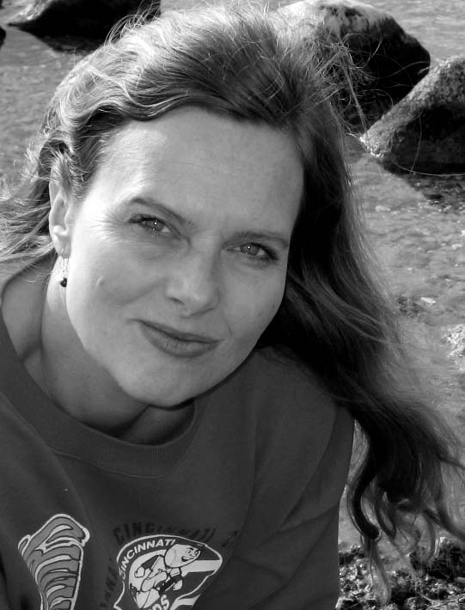

Employments:
.

Vice Chancellor at Konstfack / University College of Arts, Crafts and Design since 2012
Professor’s degree in 2012

Lector, Royal Institute of Art, Stockholm, Art&Architecture 2007-11, Professor 2011
Lector’s degree in 2007

Adjunct, Royal Institute of Art 1999-2007

Assignments:

2008-2012 Pro-Vice Chancellor Royal Institute of Art (RIA)

2009-12 Chair for the Royal Institute of Art (RIA) Board of education & research (strategy and quality)

2002-2008 Board of Swedish Arts Grants Committee (under the Ministry of Culture),

2005-08 Editor/Curator Motiv Magazine, on contemporary photography

2005-12 Critic and columnist for the Swedish public radio, SR and Dagens Nyheter (largest daily newspaper in Sweden)

2002-03 Development project for the Swedish Public Art Council: Decision-making, methods and processes in public art. Case study and proposal for a new roundabout in Åtvidaberg (with Karin Willén). Form giving of the roundabout: Lantz, Willén, LLP-architects, NIVÅ Landscaping.

1988-98 Extensive free-lance assignments within the field of urbanisation related to life-style, architecture, and identity. Travels in the Middle East, Africa, Ireland, US and Turkey.

Education:
On-going: Leadership development for Director Generals in Sweden

2012-14 Swedish Vice Chancellor leadership program, conducted by The Association of Swedish Higher Education & the Ministry of Education

2012 Personal Leadership UGL/LMDC Method

2007 ”Architecture and Imagery” higher seminar (3rd cycle) LTH, Lund

1996-98 Royal Institute of Art Post Graduate – Architecture in the public realm + Art&Arkitektur (2nd cycle)

1983-88 Valand, School of Photography, Gothenburg University (1st cycle)

1982 International Centre of Photography, New York / NYU, under-graduate, one year

Selected Exhibitions

2016 (upcoming) exhibition in Sinope, Turkey “the Sea”
2015 The Moon Bracelet, photography and the Apollo project, screening at Färgfabriken (20 min film)
2010 Bombay, Prince of Wales Museum: Informal Cities
2009 Konsthall C, Hökarängen, Stockholm, Mapping
2009 Umeå Bildmuseum, Umeå, Sweden, Mapping the Contemporary
2008 Botkyrka Konsthall, “Informalities”
2008 BB3, Bucharest Biennale, Bucharest Romania
2007 Liljevalchs, Stockholm
2007 Gothenburg Konsthall
2003 Cairo Town House Gallery ...and they got sand in their eyes. “On Location”
2002 Umeå, ”Politics of Place”, Umeå Bildmuseum

Research:

2012-15 The Moon Bracelet, on photography and the Apollo project

2001 The interdependency of Architecture and Photography (Architecture as Photography)

2007-10 Informal Cities & Dharavi - Documenting Informalities (exhibition, book, conference)

Books (selected)

2015 Radical Re Re Re Thinking [ed] Maria Lantz, Staffan Lundgren
2009- Dharavi: Documenting Informalities, Indian edition
2007- Dharavi: Documenting Informalities, European edition
2006- Urban Recreation, participation
2003- On Location 2003, catalogue, participation
2002- Politics of Place, catalogue, participation

On going assignations

Member of the advisory council for the Governor of Stockholm (2015-)
In the research committee for the Swedish Energy Authority; Energy and Design (2012-)
Member of the advisory council for the Swedish Public Art Council (2013-)

Contacts

maria.lantz@konstfack.se
Web: www.marialantz.org
Phone: +46767249777

Postal: Hornsgatan 83, 117 26, Stockholm, Sweden

